Electro Chemistry

1. a) Define electrolyte and non-electrolyte

b) Define electrolysis

c) Describe the mechanism of electrolysis

d) Describe Faraday’s law

e) Solve problem 0.1978 g of Copper is deposited by a current of 0.2 A in 50 minutes. What is the electrochemical equivalent of Copper?

a)

**Electrolyte** are electrovalent substances that form ions in solution which conduct an electric current.

Sodium chloride (NaCl), Copper sulphate (CuSO4) and Potassium nitrate (KNO2) are examples of electrolyte.

**Non-electrolyte:** On the other hand, non-electrolyte is covalent substances which exists neutral molecules in solution. This water solution do not conduct an electric current.

Sugar, Alcohol and glycerol are typical non-electrolytes.

An electrolyte individually undergoes chemical decomposition as a result of the passes of electric current through its solution.

b)

**Electrolysis:** The phenomenon of decomposition of an electrolyte by passing electric current through its solution is termed an electrolysis (Iyo-breakly)

The process of electrolysis is carried in an apparatus called the electrolytic cell. The cell contains water solution of an electrolyte in which two metallic rods (electrodes) are clipped.

There rods are connected to the two terminals of a battery. The electrodes connected to the positive (+Ve) of the battery attracts the negative ions (anion) is called anode. The other electrode connected to the negative (-Ve) end of the battery attracts the positive ion (cation) is called cathode.

c)

In electrolysis, the cation migrates to the cathode and form a neutral atom by accepting electrons from it. The anion migrates to anode and yield a neutral particle by transfer of electron to it. As a result of loss of electron by anion and gain of electron by cation as their respective electrodes chemical reaction takes place.

Example: let us consider the electrolysis of Hydrochloric acid as an example. In solution, HCl is ionized,

HCl ------------> H+ + Cl-

In the electrolytic cell, Cl- ion will move towards the anode and H+ ion will move towards the cathode. At the electrodes, following reaction will take place.

At cathode:

H+ + e- -----------> H

Each Hydrogen ion picks up an electron from the cathode to become a Hydrogen atom. Pairs of Hydrogen atoms the united to form molecules of Hydrogen gas, H2.

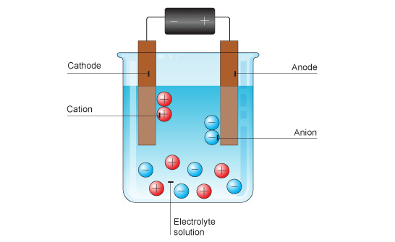

Fig: Mechanism of electrolysis.

At anode:

Cl- ------------> Cl + e-

After the chloride ion loses its electron to the anode, a pair of chlorine atom united to form chlorine gas, Cl2. The net effect is the process as the decomposition of HCl into Hydrogen and Chlorine gases. The overall reaction is:

2HCl -----------> H2 + Cl2

d)

**Faraday’s law of electrolysis:**

First law: The amount of given product liberated at an electrode during electrolysis is directly proportional to the quantity of electricity which passes through the electrolyte solution.

Mathematical expression: If m is the mass of substance (in grams) deposited on electrode by passing Q coulombs of electricity, then,

m α Q

We know that, Q = It

Where, I is the strength of current in amperes and t is the time in second for which the current have been passed.

Therefore, m α It

On, m = Zit

Where, Z is the constant known as electrochemical equivalent of the substance (electrolyte)

If I = 1 ampere and t = 1 second, then,

M = Z

Thus, the electrochemical equivalent is the amount of a substance deposited by 1 ampere current passing for 1 second. (I.e. one coulomb)

e)

Solution:

Here,

t = 50 minutes = 50 × 60 s

Quantity of electricity used is,

Q = It = 0.2 × 50 × 60

= 600 coulombs

Amount of Copper deposited by 1 coulomb = $\frac{.1978}{600}$ gm

= 0.0003296 g.

So, electrochemical equivalent of Copper = 0.0003296.